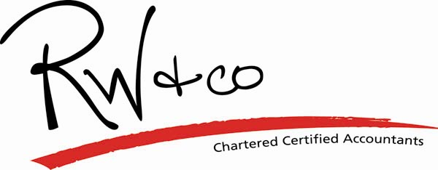

Contact us on (0191) 491 0019 for advice and tax saving advice in these areas, or email us at info@rwco.net

